Name:  Class: | ____________________________________  ________________ | Date:_________
 | Year 10 Mathematics 2018  / 24  2 Lessons  Investigation  Trigonometry  Investigation / Validation  You will need: Collaborative component:  Pen, calculator and a ruler

Y10 OLNA Investigation for trigonometry.

We will be working in groups to construct a ramp which complies with the safety standards of Western Australia.

When a slope becomes greater than 1:20 or 2.9 degrees in inclination; we must build it according to the WA regulations, anything below is not considered a ramp. These rules specify that a maximum gradient of 1:12 or 4.8 degrees in inclination cannot be exceeded.

1) Determine if the following ramp falls under the rules and if it complies: ( 3 marks )

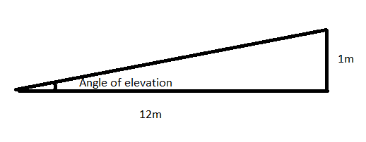
Slope = rise : run = vertical height increase : Horizontal length increase
Gradient = rise / run = vertical height increase / Horizontal length increase

Show all workings

( 3 marks )

2) Tom decides to place plywood down the stairs to make a wheelchair access. Is the following rap considered safe? Explain why or why not? Show all workings.
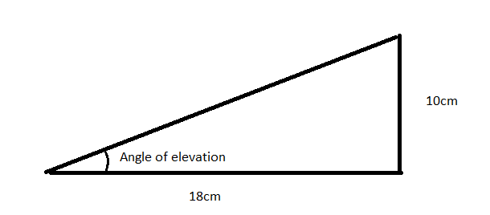

Show all workings

( 6 marks )

3) A classroom is 60 cm above the surrounding ground level. Please construct a ramp to allow wheelchair accessibility given there is only 5×5 meters of room in front to make the ramp. Please give birds eye view and side view with all measurements: If you do not have enough room to make the ramp, make half the ramp, then leave a metre flat landing around the bend and go back to double the length. Show all workings.

Birdseye view:
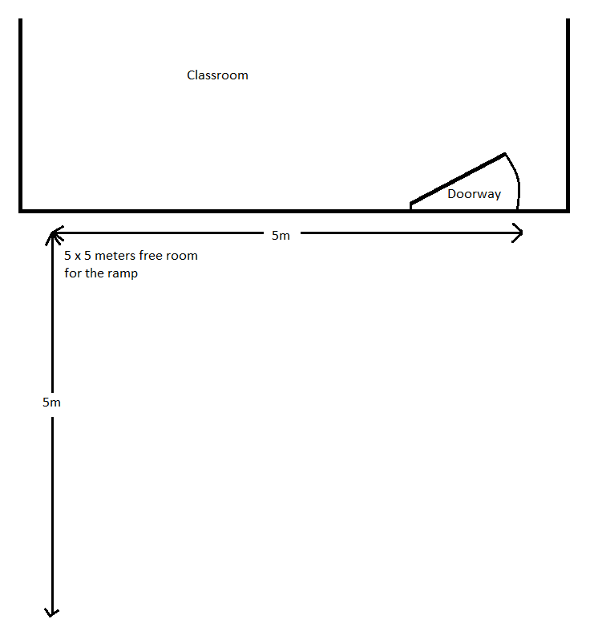

Side view:

4)

Students are to go outside, observe and measure the concrete ramp up to the D block, as well go and look at the 2 science demount-able rooms which have a wooden ramp that makes a bend.

Students are to measure the slope of both.

Slope of D block ramp: ( 2 marks )

Slope of Science-D: ( 2 marks )

( 8 marks )

5) Constructing our ramp:

There are two options for making our ramps.

Option 1 is to pour a concrete version of our ramp, which involves making a wooden cheap frame, adding iron bars and footings and pour concrete.

Option 2 is to make footings and attach a wooden frame and laying planks which are attached to the frame.

(I) For option 1, please calculate how much concrete is needed if the ramp is 1m wide and 0.15m thick.

Volume = Length of ramp (m) x Ramp thickness (m) x ramp width (m)

(II) For option 2, Please calculate how many wooden beams are needed to cover the frame if they are 1m long, 14cm wide, and have a few millimetre gap between beams. Therefore each metre of pathway uses 7 beams.

Number of beams = length of ramp (m) x 7

